**NLP and word embeddings**

**Word Representations**

NLP is one area of AI that is revolutionised by deep learning.

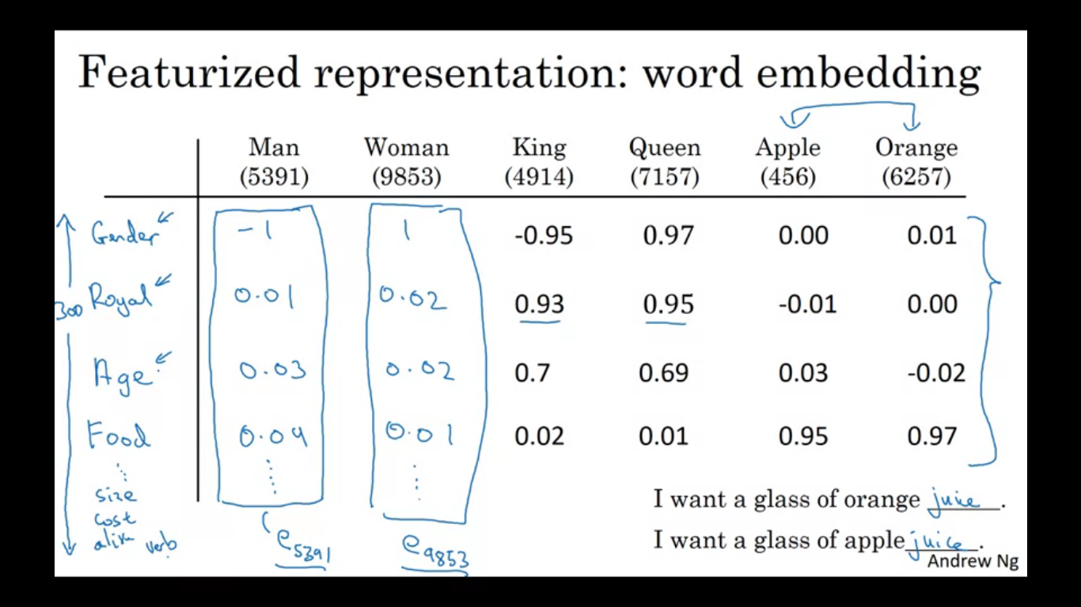

Previously we have used words as vocabulary of words. We have been representing words using a one-hot vector. One of the weaknesses of this representation is that it treats each word as a thing onto itself. It doesn’t allow an algorithm to easily generalize the cross words. Inner product between any two one hot vectors is zero.

So instead of one-hot representation we could learn a set of features and values for each of the word in the vocabulary. So for example if gender is -1 for male and +1 for female, then we get as shown. Apples and oranges are genderless. Another feature is how royal are these things, man and woman are not particularly royal, whereas king and queen are highly royal , apples and oranges not royal. Another is age, man and woman do not convey age, kings and queens are adults, whereas apples and oranges are neutral. Another feature is food, man and woman, king and queen are not food, but apples and oranges are. Other features include size, cost. For the sake of illustration we have 300 features , then each of the word becomes a 300 dimensional vector for representing the words. So if we use these representations for oranges and apples then the representation values for oranges and apples are quite similar. This increases the odds of a learning algorithm that ha sfigured out orange juice is a thing to also quickly figure out that apple juice is a thing.

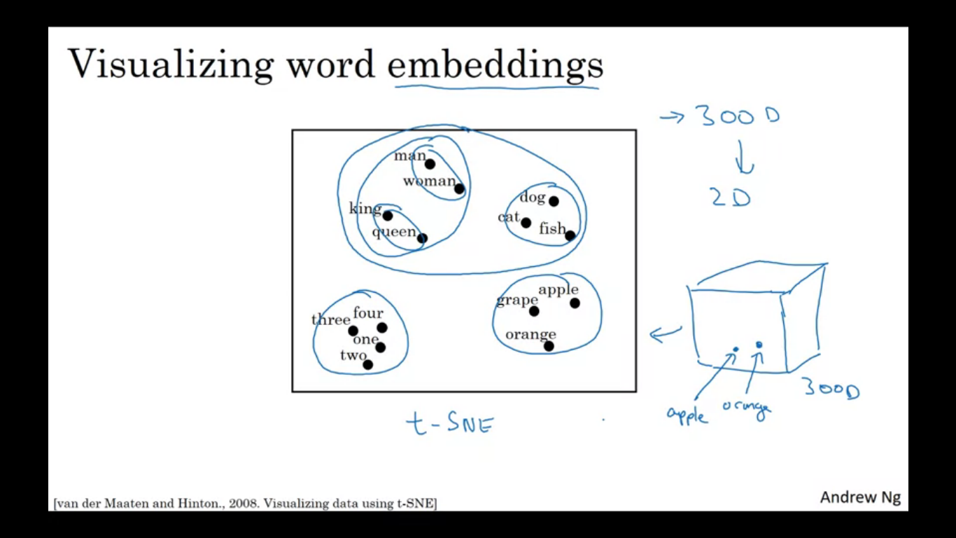

So we need to learn word embeddings which are basically learning high dimensional feature vectors like this, that gives a better representation of representing one hot vectors for representing different words. If we learn the 300 dimensional embedding, we can embed them in 2D space so we can visualise them. One algorithm to do is t-SNE algorithm. When we do so we find words with similar values tend to get grouped together. These representations use featurised representations maybe in 300 dimensional space, these are called as embeddings.

**Using word embeddings**

After having trained a model that uses word embeddings as inputs , if we now input a new sentence, knowing that oranges and apples are quite similar it will make easier to your learning algorithm to generalize that Robert lin is also a name.

If you have a small label training set for the name entity recognition task we might not see the word durian or cultivator in training set. But if you have learned a word embedding that tells you that durian is a fruit and cultivator is like a farmer then you might be able to recognise that durian cultivator is also a person’s name.

Algorithms to learn word embeddings can examine very large text corpus so by reading a large text corpus from the internet we can recognise that durian is a fruit. Then we can apply this to our named entity recognition task for which we might have a smaller training set.

This has allowed us to carry out transfer learning where we take information we have learned from huge amount of data from the internet to figure out apples, oranges and durians are fruits then use this knowledge for a task such as named entity recognition for which we have small training set.

**Transfer learning and word embeddings**

We can now use relatively lower dimension feature vectors so rather than using 10000 dimensional one hot vectors you can use 300 dimensional dense vectors. Finally we can continue to adjust the word embeddings with the new data.

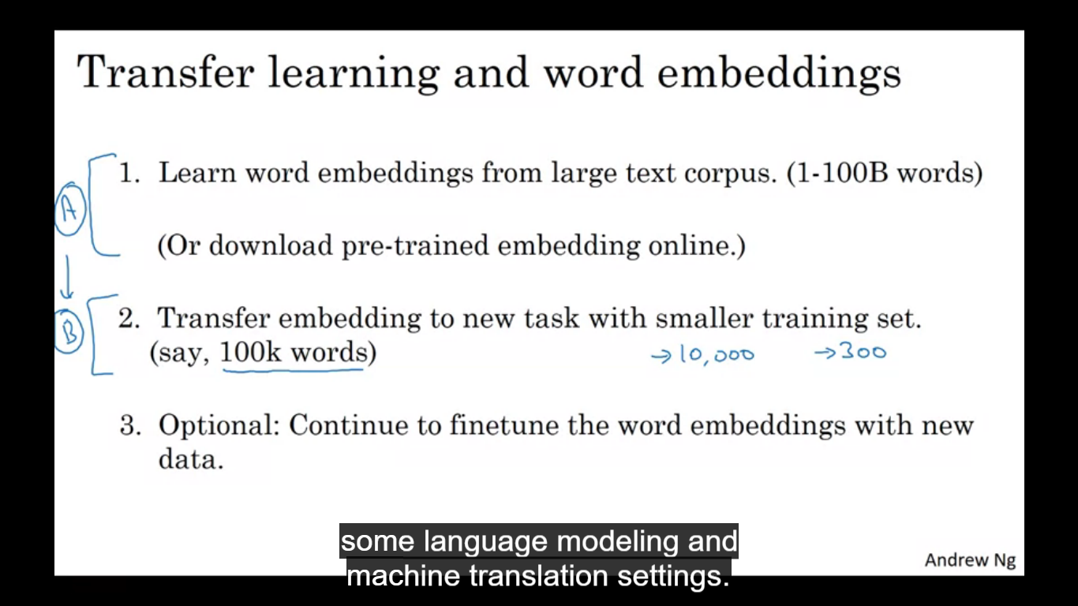

Word embeddings make the biggest difference when the task we are trying to carry out has a relatively smaller training set. Transfer learning is only useful when we have a ton of data A and we transfer the knowledge for relatively smaller data.

We have e1-e1000 which learns a fixed embedding for each of the words in our vocabulary.

**Properties of word embeddings**

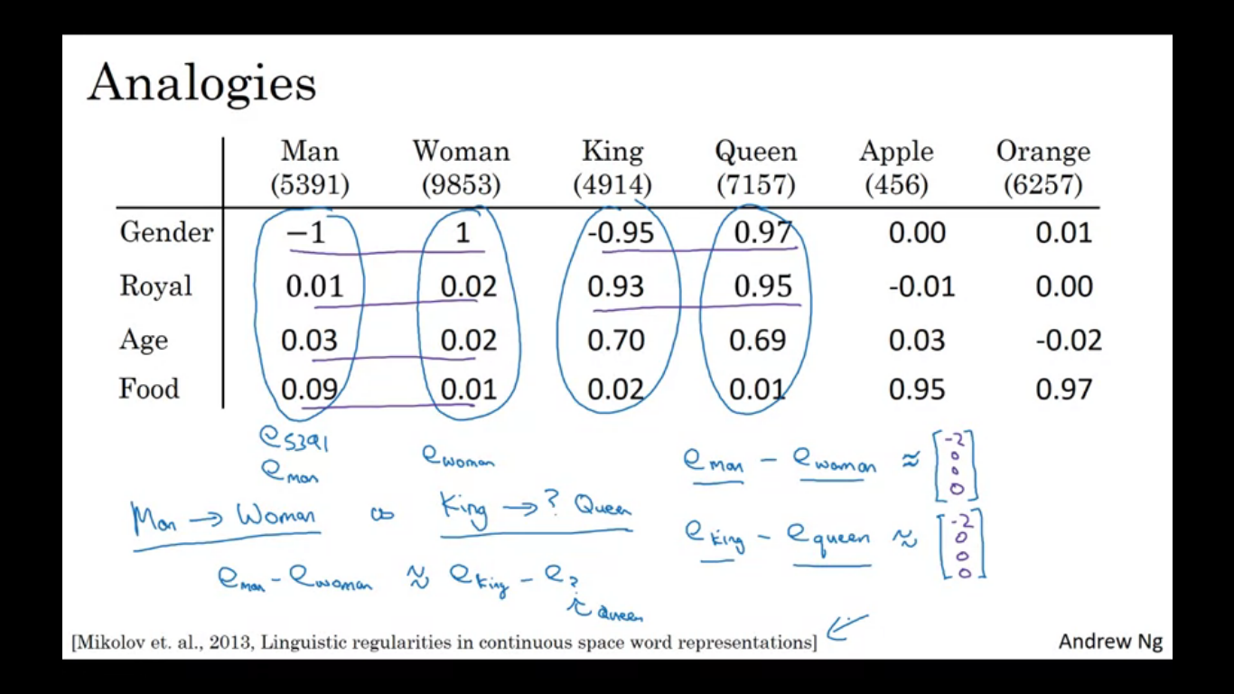

Word embeddings can also help with analogy reasoning , these can give an insight into what these word embeddings can do.

Man-> woman , so king->? . how can we have the algorithm figure out what is there in place of ?.

We are using this 4D vector to represent a man e_man , e_woman and we also have 4D embeddings for king and queen. If we take the vector eman and subtract the vector ewoman then we get a 4D vector of difference, similarly we get the same for eking-equeen. So what we see the main difference between man and woman is basically gender and difference between queen and king as represented here is also the gender. So difference eman-ewoman and he difference eking and equeen are about same. So it turns out that queen is the answer for ‘?’

**How to turn the above into an algorithm?**

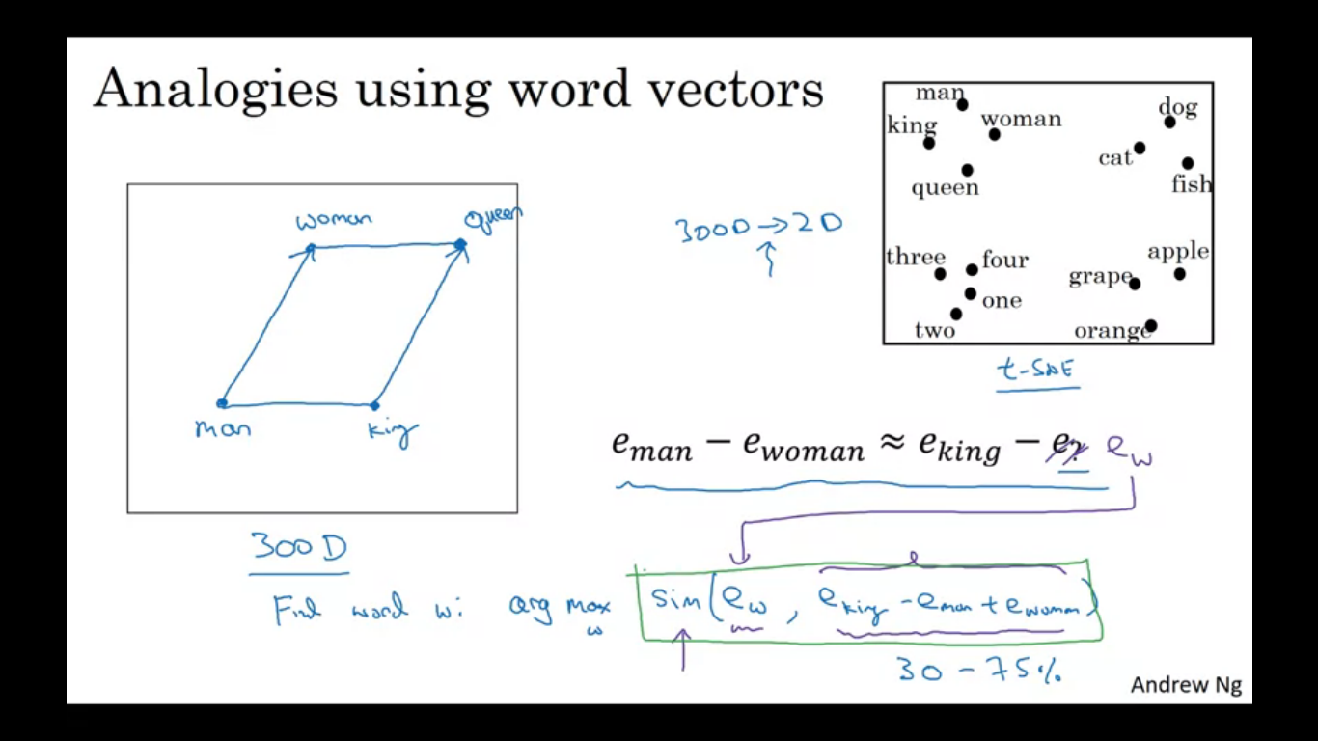

In pictures word embeddings live in 300D space. So the arrow drawn is the difference for the dimension of the gender. We need to find the word W so that the similarity of the word is maximised for the equation eking-eman+ewoman a shown in the figure.

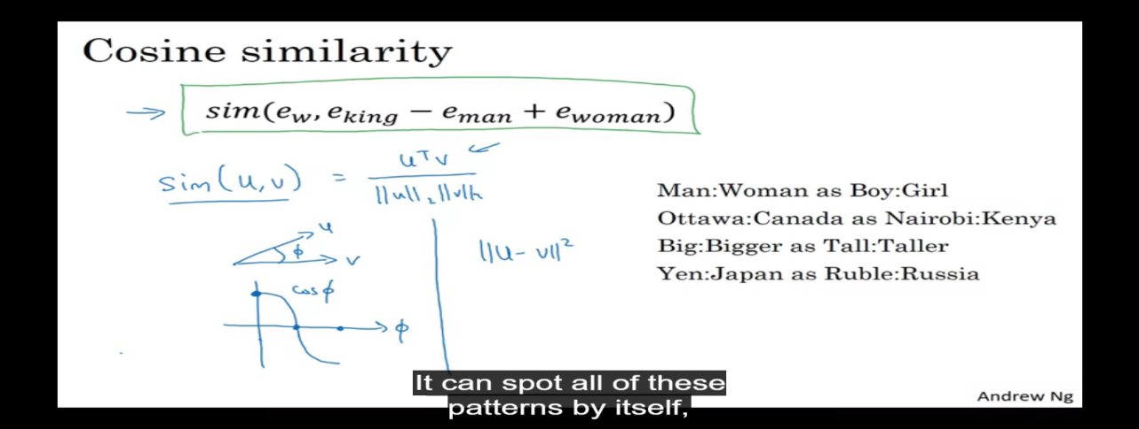

The most commonly used similarity function is called cosine similarity. If u and v are very similar then the product will be large. We can also use squared distance , technically this will be a measure of dissimilarity rather than similarity.

The reasoning analogies can be learned by running a word embedding algorithm on a large text corpus.

**Embedding matrix**

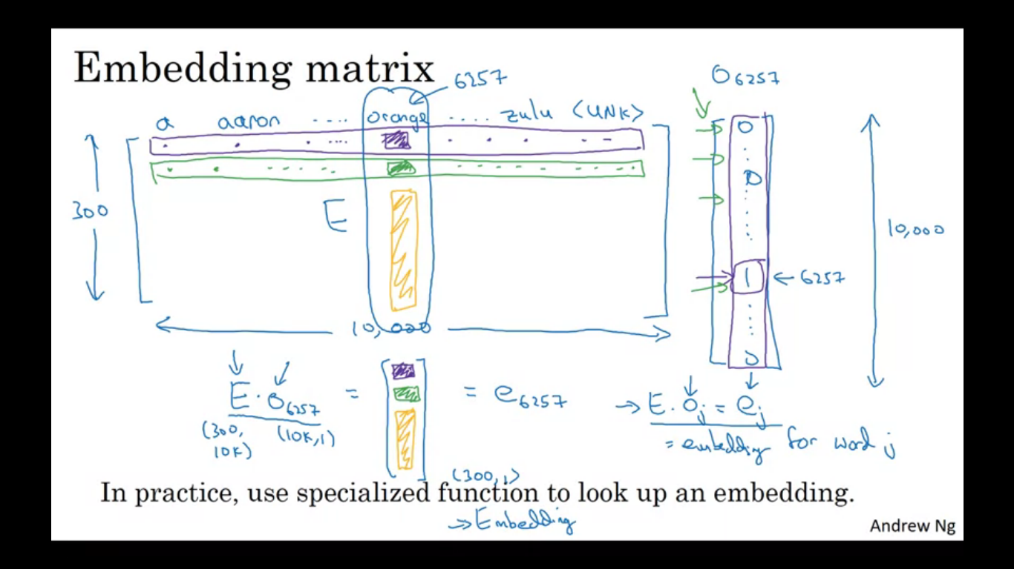

When you apply an algorithm to learn word embedding what you end up learning is an embedding matrix.

Let’s say we are using our previously used 10000 word dictionary. So we are going to learn an embedding which is (300, 10000) dimensional matrix. The columns of this matrix is the 10000 different words you have in your vocabulary. The embedding matrix is called E, and when we multiply E with one-hot vector of O6257 then we get a 300 dimensional vector. So essentially we get the complete orange column from the word embedding matrix.

So E. Oj = ej which is the embedding for word j in the embedding matrix.

Since it is a one hot vector and most of the elements is actually zero, so it is not efficient to implement vector multiplication to implement this. In practice we just used a function to get to the column e rather than doing matrix multiplication.

In keras we have the embedding layer which just out the column we want from the embedding matrix rather than doing it with a much slower matrix vector multiplication.

**Algorithms for learning word embeddings**

Let’s say we are building a language model and we do it with a neural network. We input a sentence and we want to predict the next word for an input sequence. The numbers below each of these words are the index in the vocabulary. Next we create one hot vector (O) of the words then as done previusoly we have an embedding matix E and E.O will give us the embedding vector e4343. We do it with all the words in the sentence. We get as shown.

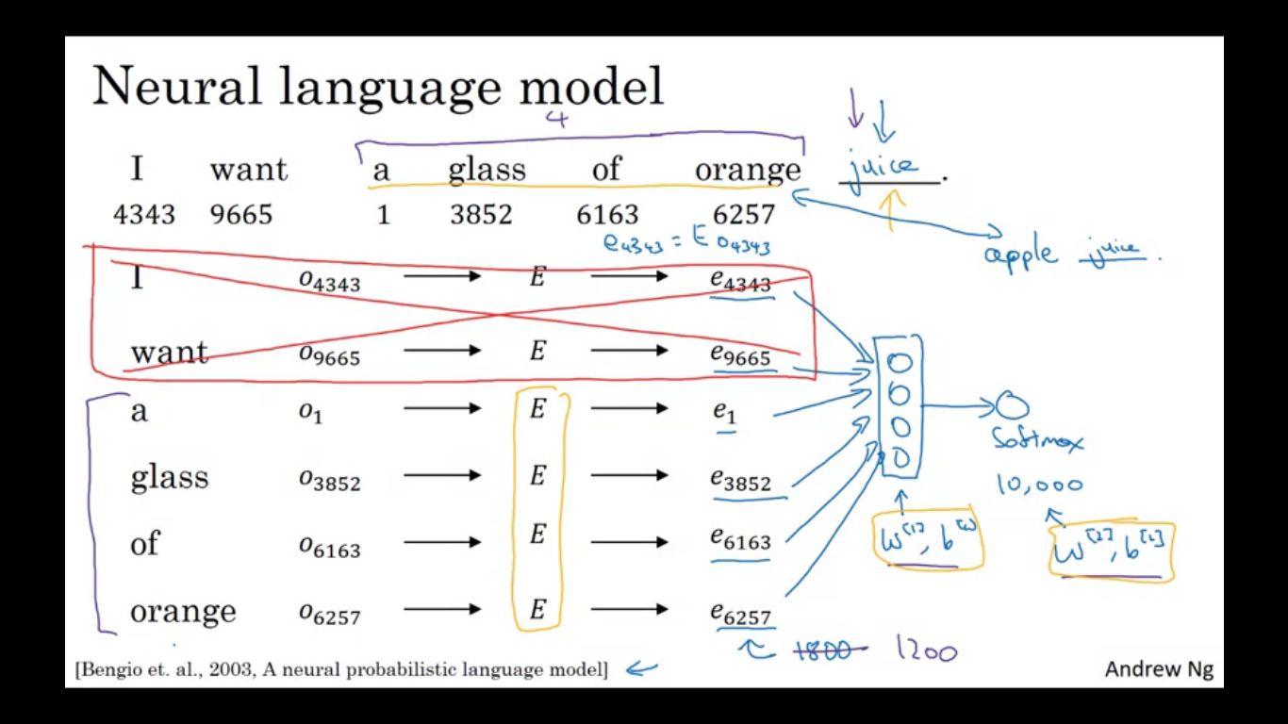

We now have 300 dimensional embedding vector. Next we can feed all of them into a NN. The NN feeds to a softmax which has its own parameters as well and it classifies the 10000 words in the vocabulary for the final word we are trying to predict. The NN layer and softmax layers will have their own parameters w[1],b[1] and w[2],b[2]. We are using six words and each word is a 300 dimensional so we have an 1800 dimensional input layer obtained by stacking six embedding vectors and stacking them together.

Other way is to have a fixed historic size window, which means the next word let’s say depends upon previous four words where four is the hyper parameter of the algorithm. So if we are input a four word history then our NN will input 1200 dimensional input vector.

Having a fixed history means we can deal with arbitrarily long sentences as the input size is always fixed. The parameters of the algorithm are marked in orange and we can use back prop to perform GD to maximize the likelihood of training set.

This will work well, because as seen orange and apple will have pretty similar word embeddings and doing so allows to fit the training set better.

Even simpler algorithms

We illustrate other algorithms using a more complex sentence as example.

We had task of predicting orange juice and it was given some context which was the last four words.

For learning problem the context is four words on the left, whereas for other tasks we could have different learning models. Posing a learning problem where we have embeddings of the left four words and right four words feed into a NN to find out the word in the middle.

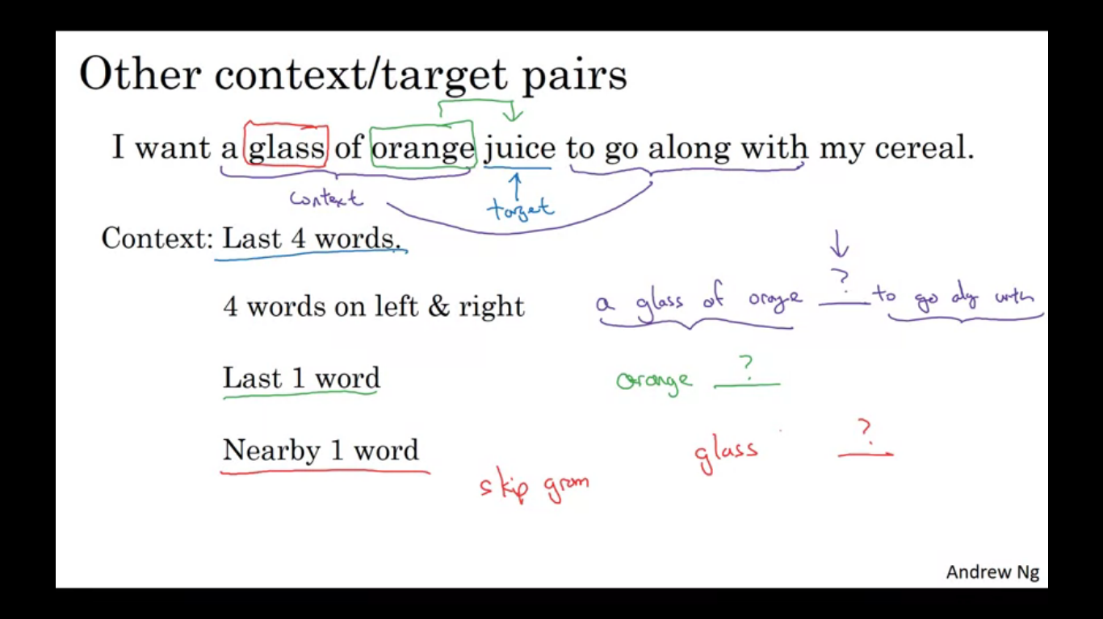

So we can have different contexts for different learning problems, like last four words, four words on the left and right, last 1 word, nearby 1 word is the idea of the skip gram model where the concept is to have 1 word rather than four words.

If we want to build a language model, then previous words is required, but if we want to learn a word embedding then we can use all these other contexts and they will result in meaningful word embeddings as well.

**Word2vec algorithm**

It is a simpler and computationally more efficient way to learn embeddings.

Let’s say we have this sentence in the training set. In the skip gram model we come with a few context to target errors to create our supervised learning problem. So we randomly pick a word as a context word, let’s say we chose the word orange and we also pick another word within some window say +-5/10 words and we choose that to be the target word. So just by chance we might pick juice to be a target word or you might choose two words before so we have another pair where target would be glass. So we set up a supervised learning problem where given a context word you are asked to predict a randomly chosen word within a +-10 word window of that input context word.

The goal of setting the supervised learning problem is not to do well on the supervised learning problem per se, we want to use this problem to learn good word embeddings.

**The model**

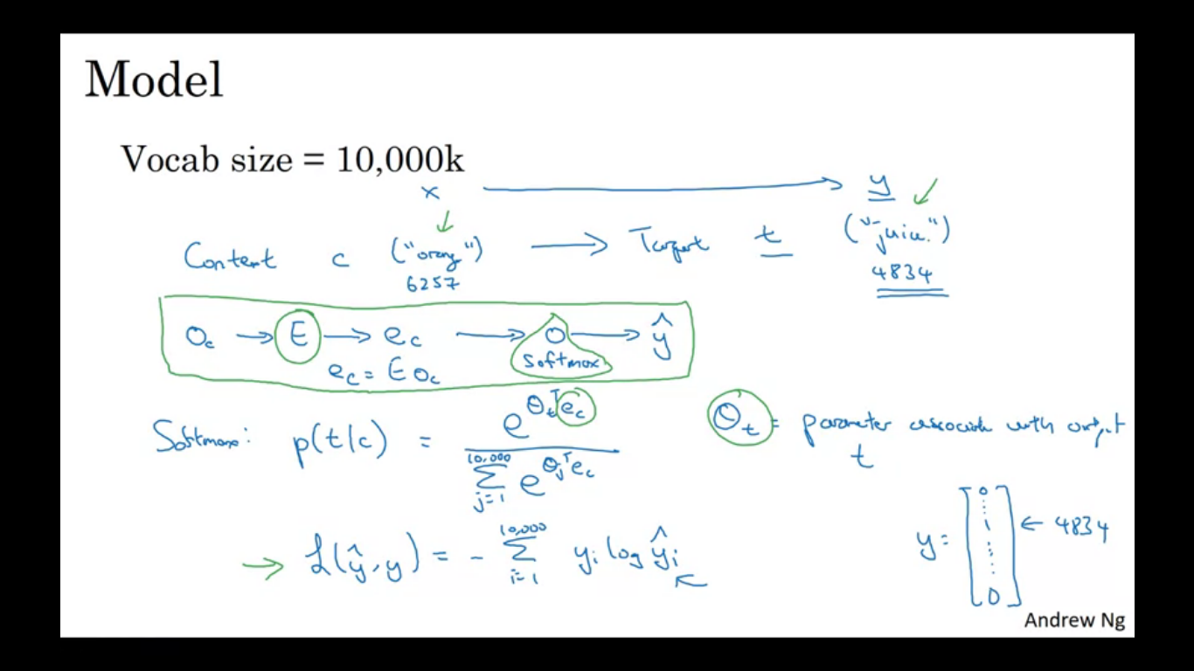

We have a context which we want to map to a target. To represent the input we can start with some one hot vector Oc which is a one hot vector of context words we can take the embedding matrix E, do E.Oc to get ec. We then feed the ec to a softmax unit . The softmax unit estimates probability of different target words given the input context words as shown in the figure. Where thetat is the parameter associated with output of a particular word t. The loss function for the softmax will be the usual. We use one hot vector for y and yhat. Y is a one hot vector containing 1 only for the word in the vocabulary, and yhat is a computed from softmax quantity which has probability values for all 10000 words.

The above is called the skip-gram model as it is taking as input 1 word like orange and then to predict some words skipping a few words on the left and right side.

**Problems with using this algorithm**

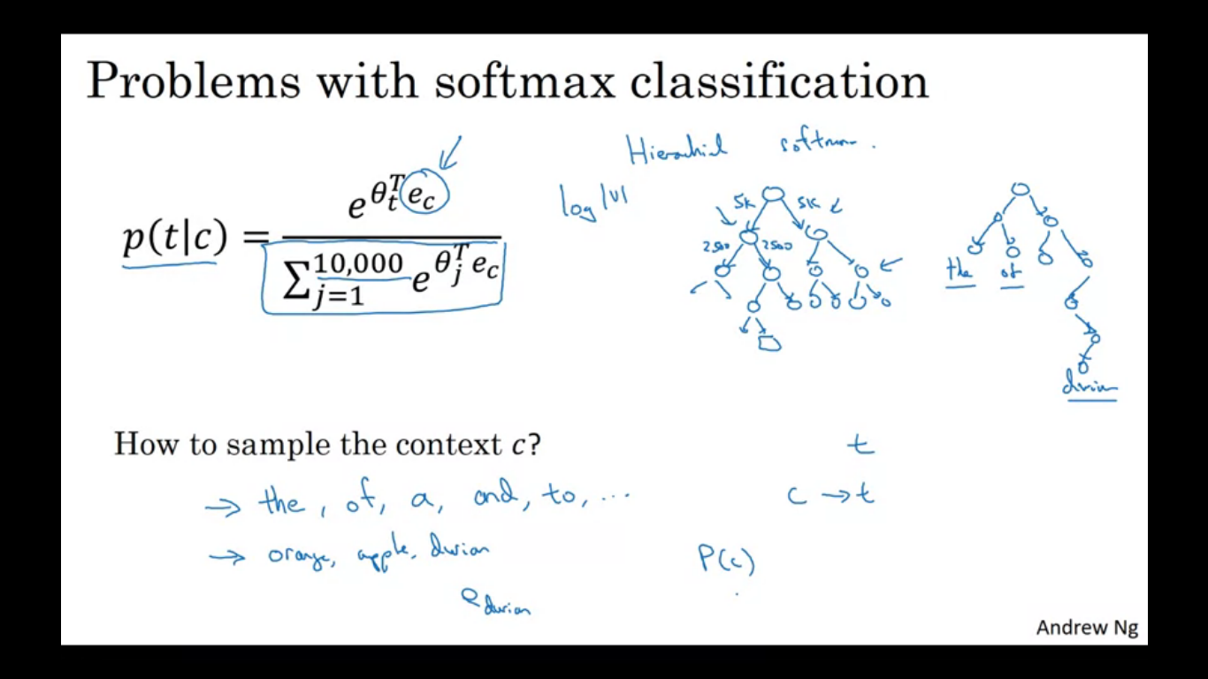

Primary problem is computational speed. For a softmax model, everytime we want to evaluate this probability, you need to sum over all 10000 words in your vocabulary. If we are using a vocabulary of size >10000 it gets really slow to sum up over this denominator every single time.

Possible solution to this is using a hierarchical softmax classifier. Instead of trying to categorize all 10000 categories in one go imagine if you have one classifier, which tells you is the target word in the first 5000 words or the second 5000 words of the vocabulary. Let this classifier tell you it is in the first 5000 words. Then it tells if it is in first 2500 words of vocabulary or second 2500 words of vocabulary. And continue till we get the answer as the leaf of this tree. Having a classifier like this tells us that interior nodes of a tree are just binary classifier. The computational cost scales like log of the vocabulary size. In practice the hierarchical softmax classifier does not use a perfectly balanced tree. It is created as common words on the top and much less common are buried deep inside the tree. We see common words more often so we need less frequent traversal of tree.

**How to sample the context c?**

The target t can be sampled within say a +-10 word window of the context c but how do we choose the context c . one thing to do is sample uniformly at random from your training corpus. When we do so we find that the words like the, of, a, and, to appear frequently. You find that in your cnontext to target mapping pairs to get these type of words extremely frequently whereas there are other words which don’t appear that often. We don’t want our training set to be dominated by these frequently occurring words as then we would be using much of our efforts updating ec for these words.

In practice pc is not taken just entirely at random but instead there are different heuristics that you could use to balance sampling from common as well as less common words.

**Negative sampling**

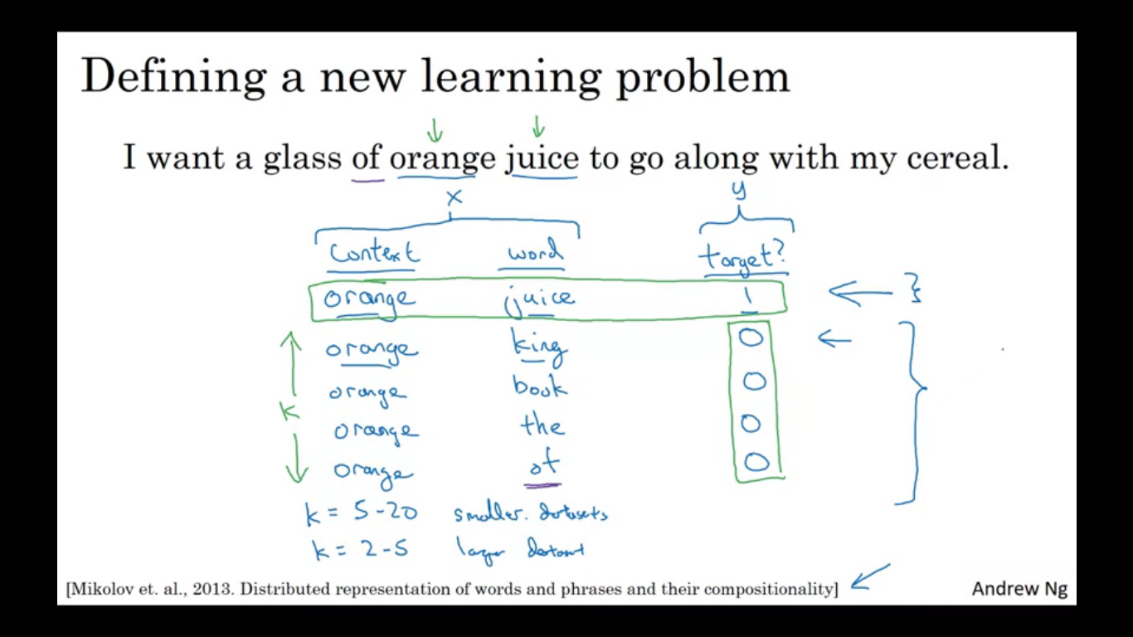

Create a new supervised learning problem, given a pair of words like orange or juice we are going to predict is this a context target pair. So in this example orange juice is a positive example so 1 and orange king is a negative example so we write 0 for the target. So we sample a context and a target word. To generate a positive, sample a context word, look around a window of +-10 words (say) pick a target word. To generate the negative example take the same context word and pick a word at random from the dictionary and label as 0.

The dataset shown is generated as we pick a context word and pick a target word and we get the first row of the table. Next for k times we take the same cont ext words and then pick random words from the dictionary and label all those 0 and those will be our negative examples.

Then we are going to create a supervised learning problem where the learning algorithm inputs x which is the pair of words and it has to predict the target label to predict the output y. Do you think I got these two words by sampling the two words close to each other or do you think I got them as one word from the text and one word chosen at random from the dictionary. K is perhaps 5-20 for smaller datasets an if we have very large dataset then choose k to be smaller (2-5)

Next let’s describe the supervised learning model for learning a mapping from x to y

We define a logistic regression model we define

Shown in figure also

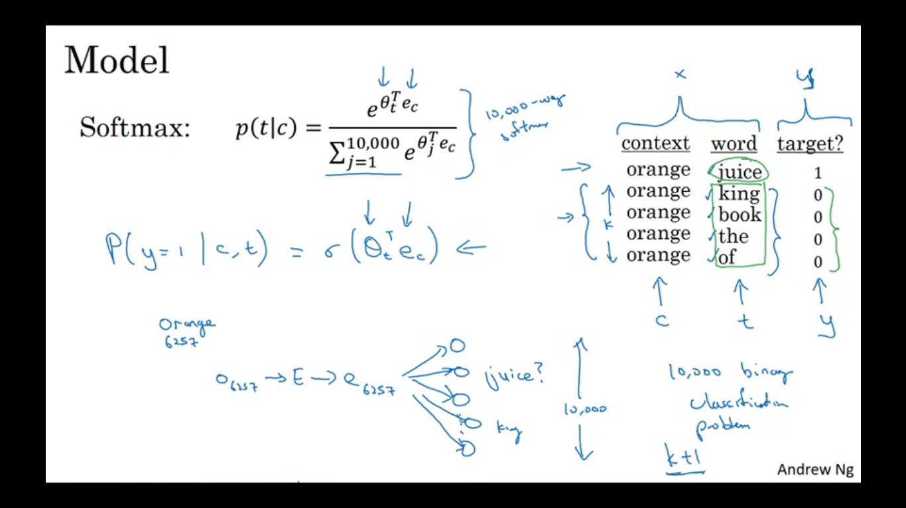

P(y=1/c,t) = sigmoid(thetat(T) ec)

We use the formula to estimate the probability that y=1, so if we have k negative examples, then we have k:1 ratio of negative to positive examples. So we pass in the one hot vector of the word orange and pass it to E and then get the embedding vector e6257. Then we have 10000 possible logistic regression problem, Where one of these will be a classifier corresponding to is the target word juice or not. So this is like having 10000 binary regression classifiers but instead of training all 10000 of them on every iteration we are only going to train five of them. We will train the one corresponding to actual target word and train four randomly chosen negative examples. So instead of having 1 10000 way softmax which is very expensive to compute, we have turned them into 10000 binary classification problem each of which is quite cheap to compute and on every iteration we are going to train 5 of them or k+1 of them where k negative examples and 1 positive examples. And this is why the computation cost of this algorithm is much lower since updating k+1 logistic binary classification problems. This is cheaper in comparison to updating a 10000 way classifier.

This technique is called negative sampling because what we are doing is we have a positive example and then we generate deliberately a bunch of negative examples, hence the name negative sampling.

**How do we choose the negative examples?**

We sample them according to the empirical frequency of words in your corpus. So we sample it according to how often different words appear. The problem with that is we end up with a very high representation of the words the, of, and, etc. Another extreme is when we use (1/vocabulary size) sample the negative examples uniformly at random but that is also very non representative of the distribution of English words. So the best is to sample the frequency of the word to the power of ¾

If f(wi) is the observed frequency of a particular word in the English language, then by taking it to the power of ¾ is the middle way between taking uniform distribution and observed distribution of the training set.

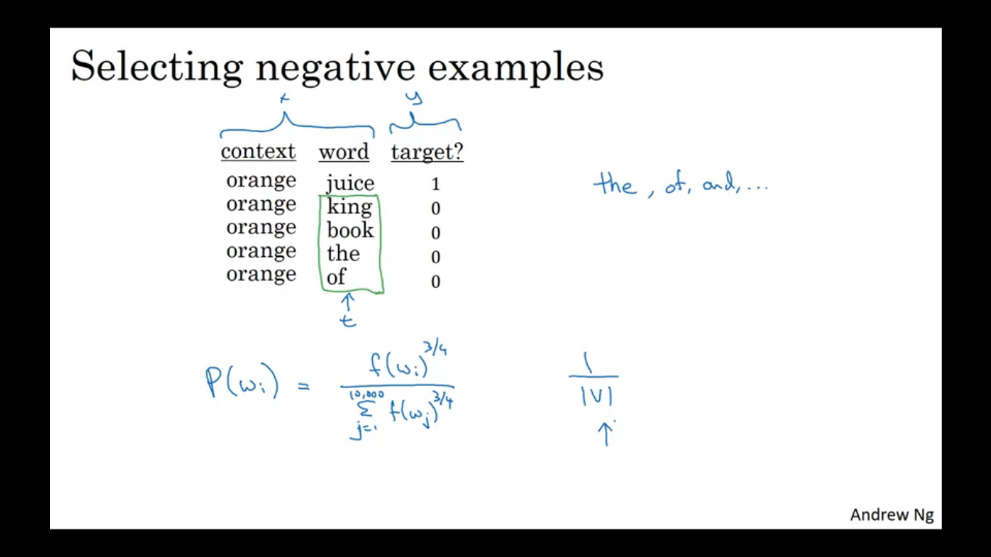

**GloVe algorithm**

GloVe stands for global vector for word representation. Previously we were sampling pairs of words, context and target words by picking two words that appear in close proximity to each other in our text corpus. Let Xij be the number of times the word i appears in the context of j. Here j=t and i=c. If we are defining context and target terms of whether they appear +-10 words of each other then it would be a symmetric relationship. Although if the choice of context is that the word is immediately before the target word then Xij and Xji may not be symmetric. So Xij is a count that captures how often do words i and j appear with each other or close to each other.

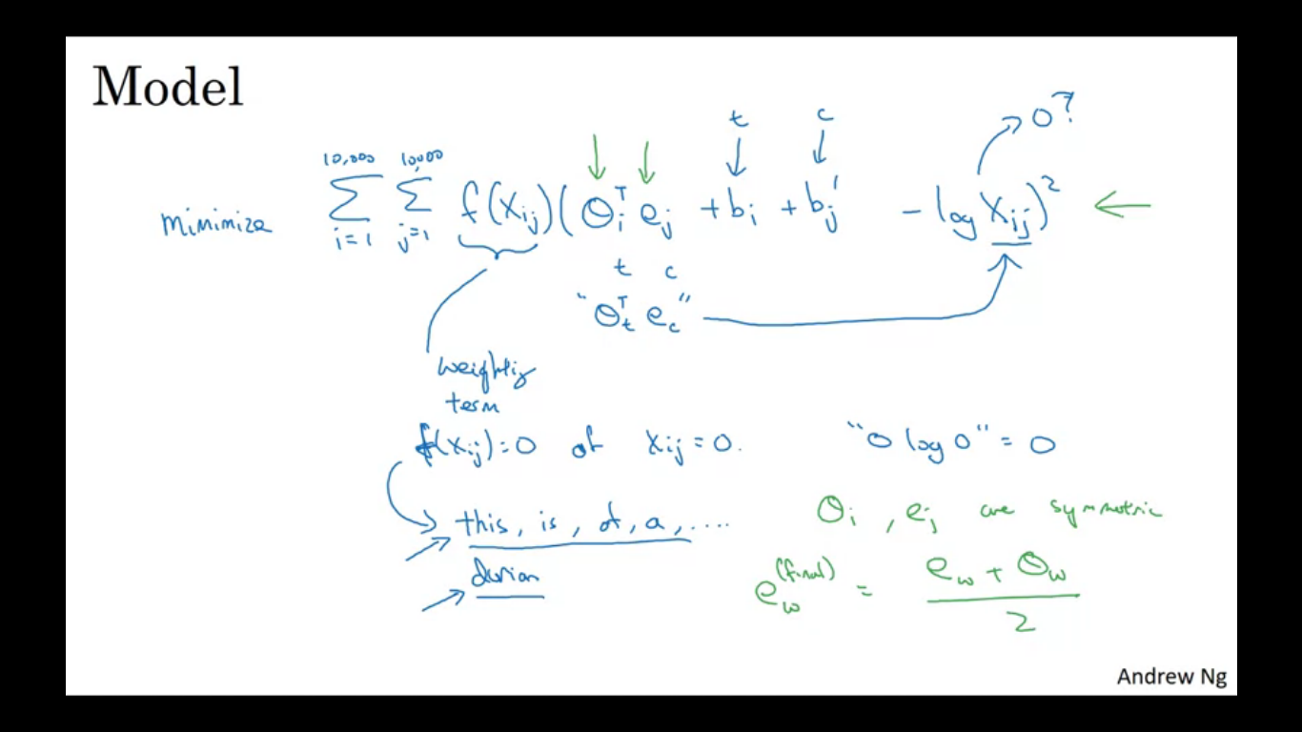

We will minimize the difference as shown in the equation. We want this to tell us how related are the two words t and c / i and j as measures by how often they occur with each other. So we solve for parameters theta and e using GD to minimise the sum over i=1-10000 sum over j=1-10000.

We want to earn vectors so their inner products is a good predictor for how often the two words occur together. If Xij=0, then log 0 is –infinity, so we won’t sum over terms where Xij is equal to zero. So we add an extra weighting term and this will be equal to 0 if Xij is equal to zero. We use a convention that 0log0=0. So adding this measn to sum over only those pairs of words that have co-occured at least once in that context target relationship. There are some words that just appear very often in English language and there are also some infrequent words, o the weighting factor can be a function that gives a meaningful amount of computation to less frequent words and more weight but not unduly large amount to words which appear lot in language. Thetai and ej are symmetric and so can be reversed and they actually end up with same optimization objective.

One way to train this algorithm is to write theta and e at random and run GD to minimise this objective and then when we are done or every word then take the average.

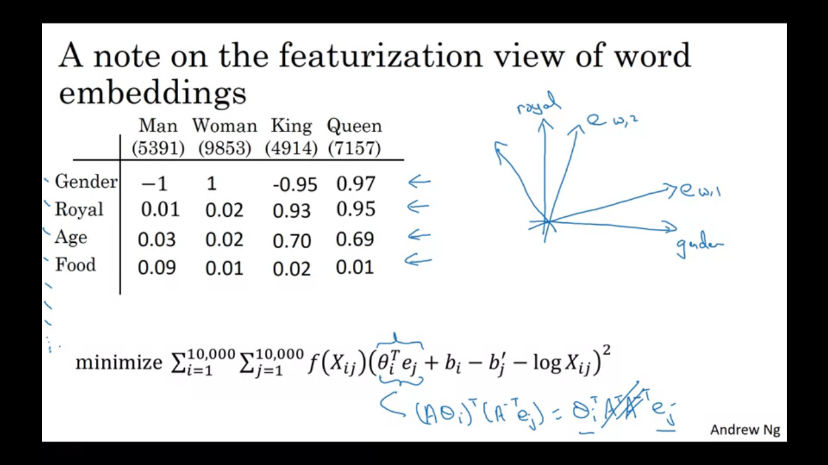

Word We started with this above featurization view as motivation for learning word vectors , when we learn word embeddings from the glove algorithm we can not guarantee the individual components of the embeddings are interpretable. With an algorithm like this we can’t guarantee that the axis used to represent the features will be well aligned with what might be easily human interpretable axis. So the first feature might be a combination of many other features. So it is difficult to look at individual rows and assign a human interpretation to that.

**Sentiment Classification**

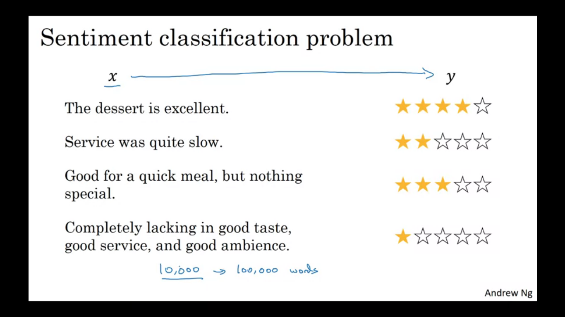

It is looking at a piece of text and telling if someone likes or dislikes the thing they are talking about. A shortcoming is that we might not have a huge labelled training set for it. But with word embeddings we will be able to build good sentiment classifiers even with modest size labelled training set.

The input x is a piece of text and output y is to predict the sentiment. For this task we have a dataset from10000 words to maybe 100000 words.

**Simple sentiment classification model**

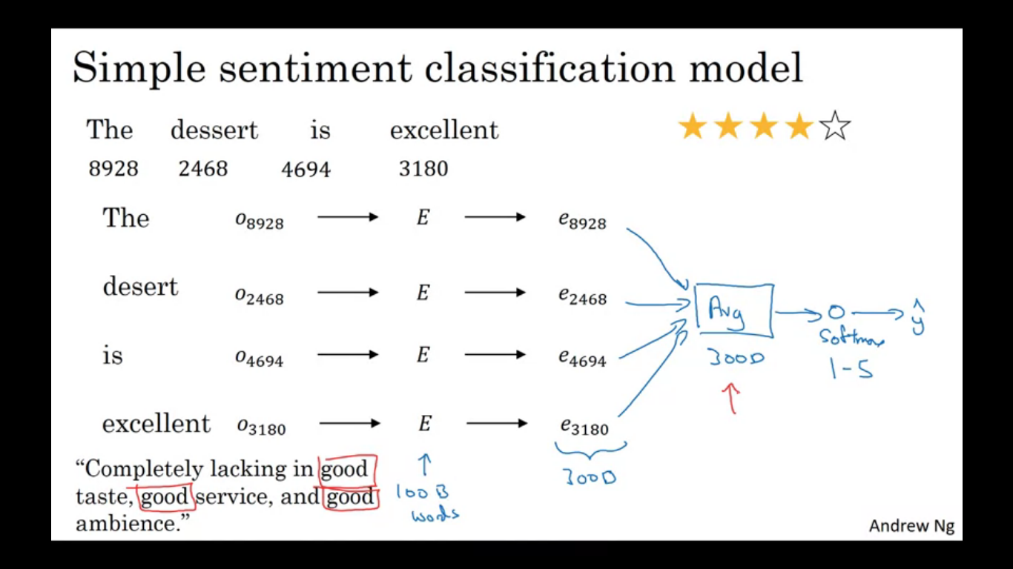

We look up the words in the dictionary. Find their one hot encoding multiply by the embedding matrix E which we can learn from a much larger text corpus and use that to extract out the embedding vector for the words. If E comes from a very large dataset then it applies knowledge to infrequent words and apply them to problem for even the words that weren’t in your labelled training set.

Next to build classifier, we can take the words which are let’s say 300 dimensional vector and you could just sum or average them. This gives a 300D feature vector that you then pass to a softmax classifier which then output Yhat. The softmax outputs probabilities of the five possible outcomes from one star to five star. It just averages or sums the meaning of all the words in your example.

One problem with this is algorithm is it ignores word order. For example there is a sentence with a lot of words good, but it is a complete negative review. So if you use an algorithm like this that ignores word order and just sums/averages the embeddings for the different words then we end up with a representation of lot of good in your final feature vector and the classifier will think it is a good review even though it is bad.

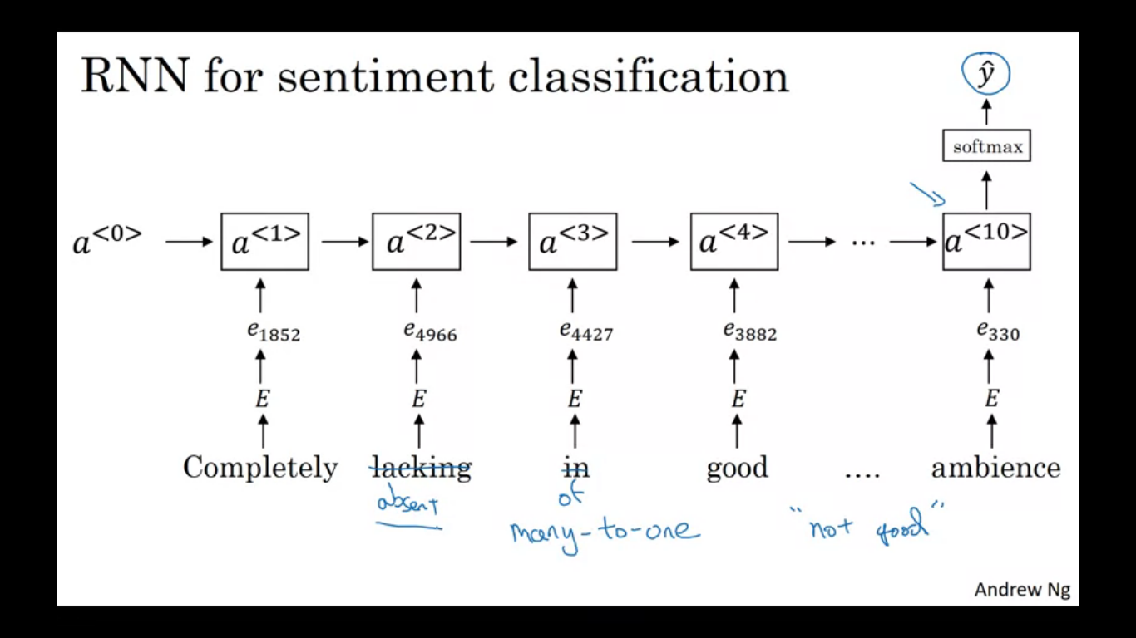

So instead of just summing all the word embeddings you can instead use an RNN for sentiment classification. So for each we find the one hot encoding multiplied by embedding matrix E, giving the embedding vectors which we can feed into an RNN and the job of the RNN is to compute a representation at the last time step that allows us to predict yhat. An example of many to one RNN structure.

**Debiasing word embeddings**

We want to diminish/eliminate the forms of bias in word embeddings. So if we ask man:computer programmer then woman is to ? the algorithm gives out homemaker, which is just wrong and it enforces a very unhealthy gender bias. So the ideal out put is woman is to computer programmer as well.

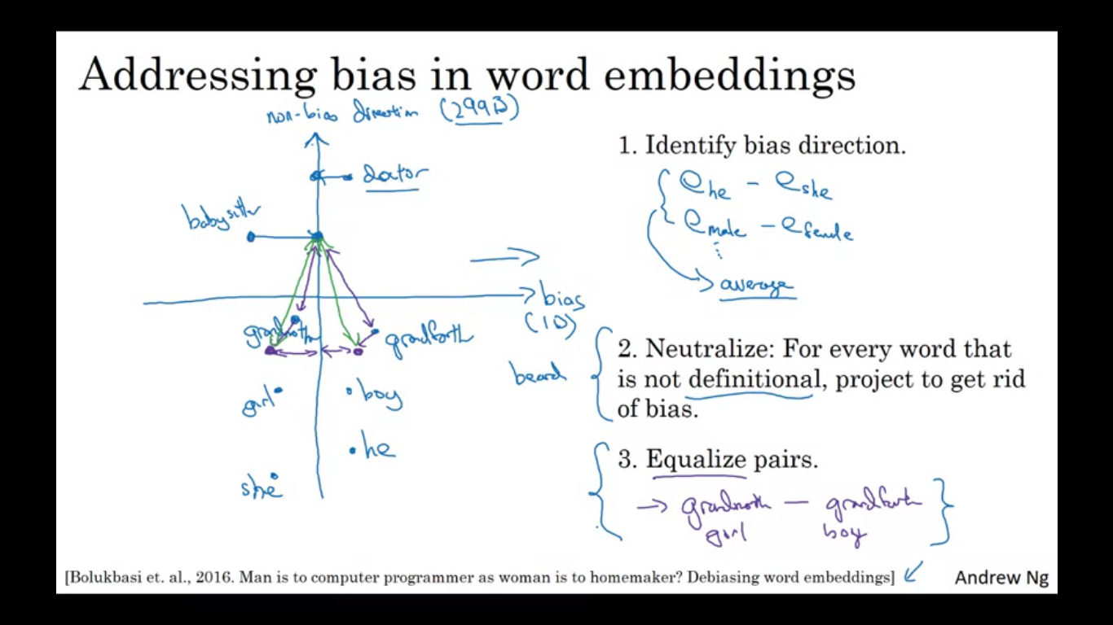

Word embeddings can reflect gender, ethnicity, age, sexual orientation and otherbiases of text used to train the model. The biases the model pick up tend to reflect the biases in text as written by people over many decades/centuries.

**Addressing bias in word embeddings**

Let’s say we have already learned a word embedding. First thing to do is to identify the direction corresponding to a particular bias we want to reduce/eliminate. For the case of gender we can have the subtraction of embedding vector of he and she and male and female and average a few of them. So in this case the bias direction is a D subspace whereas non bias direction are 299 directions. The next step is a neutralization step so for every word that is not defintional (containing a gender term) project it to get rid of the bias. There are some words that intrinsically capture gender the words like grandmother, grandfather, girl, boy, she, he a gender is intrinsic in the definition. Whereas there are other words like doctor and babysitter which we want to be gender neutral . so we project the words like doctor on the axis to reduce their component in the bias direction. The final step is called equalization in which we might have a pair of words like girl and boy where we want the only embeddings to be in their gender. In this example the distance/ similarity between babysitter and grandmother is smaller than grandfather and this ends up reinforcing the bias that grandmothers tend to babysit more than the grandfathers. So in the final step we want the words like grandmother and grandfather to be at the exactly at the same distance from words that should be gender neutral like doctor and babysitter. It will basically move grandmother and grandfather to a pair of points that are equidistant from the axis in the middle.

How do we decide what words to neutralize?

Train a classifier to try to figure out what words are definitonal .i.e. whatwords should be gender specific and what words should not be